

|  |  |  |  |  |  |  |  |  |
| --- | --- | --- | --- | --- | --- | --- | --- | --- |
|  | | | | | | | | |
|  | | DB LAB 05 | | | | |  | |
|  |  | | | | | | |  |
|  | | | |  |  | | | |
|  | | | | Basil Ali Khan(20K-0477) |  | | | |
|  | | | | 4 October 2022—Database and Management System Lab—Sir Ahmed Budhi |  | | | |
|  | | |  | | |  | | |

**Task#01:**

SELECT e.FIRST_NAME, e.JOB_ID, d.DEPARTMENT_NAME, e.SALARY,

CASE WHEN e.SALARY > 20000 THEN 'GRADE 01'

WHEN e.SALARY > 10000 THEN 'GRADE 02'

WHEN e.SALARY > 5000 THEN 'GRADE 03'

ELSE 'GRADE 04' END

AS GRADE

FROM HR.EMPLOYEES e INNER JOIN HR.DEPARTMENTS d ON e.DEPARTMENT_ID = d.DEPARTMENT_ID

ORDER BY d.DEPARTMENT_NAME;

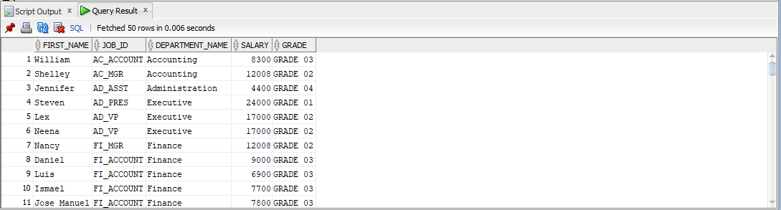

**Task#02:**

SELECT d.DEPARTMENT_ID, COUNT(e.EMPLOYEE_ID) AS NUMBER_OF_EMPLOYEES

FROM HR.DEPARTMENTS d INNER JOIN HR.EMPLOYEES e ON d.DEPARTMENT_ID = e.DEPARTMENT_ID

GROUP BY d.DEPARTMENT_ID

HAVING COUNT(e.EMPLOYEE_ID) >= 2;

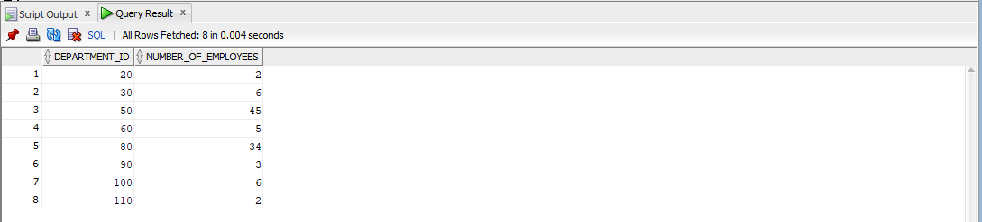

**Task#03:**

SELECT *

FROM HR.EMPLOYEES e LEFT JOIN HR.JOBS j ON (e.JOB_ID = j.JOB_ID)

WHERE e.SALARY < j.MIN_SALARY;

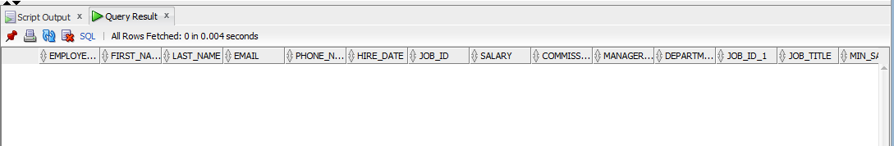

**Task#04:**

SELECT d.DEPARTMENT_ID, d.DEPARTMENT_NAME

FROM HR.DEPARTMENTS d LEFT JOIN HR.EMPLOYEES e ON d.DEPARTMENT_ID = e.DEPARTMENT_ID

WHERE e.EMPLOYEE_ID IS NULL;

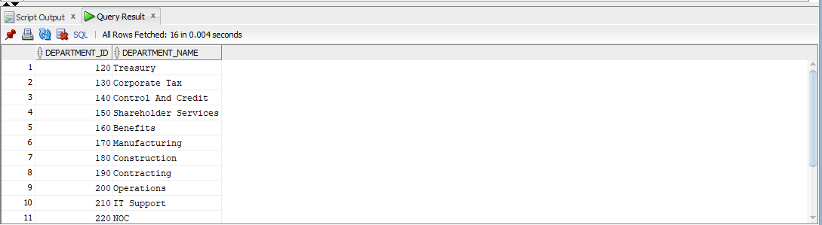

**Task#05:**

SELECT e.FIRST_NAME, e.LAST_NAME, e.SALARY, d.DEPARTMENT_NAME, e.DEPARTMENT_ID AS L_DEPARTMENT_ID, d.DEPARTMENT_ID AS R_DEPARTMENT_ID

FROM HR.EMPLOYEES e LEFT JOIN HR.DEPARTMENTS d ON e.DEPARTMENT_ID = d.DEPARTMENT_ID

ORDER BY e.FIRST_NAME;

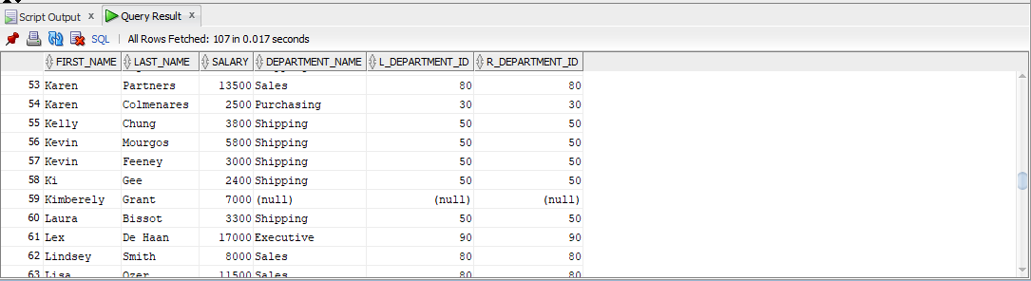

**Task#06:**

SELECT e.FIRST_NAME, e.LAST_NAME, e.SALARY, d.DEPARTMENT_NAME,

CASE WHEN e.SALARY > 20000 THEN 'GRADE 01'

WHEN e.SALARY > 10000 THEN 'GRADE 02'

WHEN e.SALARY > 5000 THEN 'GRADE 03'

ELSE 'GRADE 04' END

AS GRADE

FROM HR.EMPLOYEES e LEFT JOIN HR.DEPARTMENTS d ON e.DEPARTMENT_ID = d.DEPARTMENT_ID

WHERE e.SALARY >= 5000;

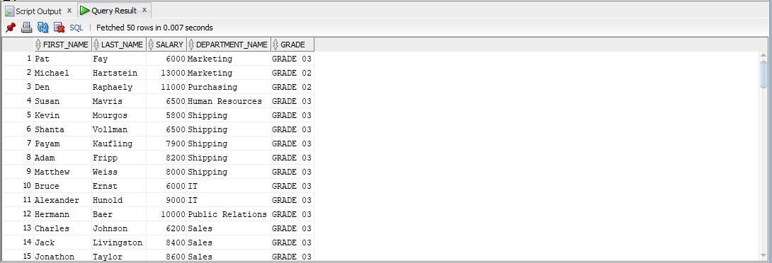

**Task#07:**

* Analyst was not there so consider PU_CLERK….

SELECT e.FIRST_NAME, e.LAST_NAME, e.JOB_ID, e.SALARY * 12 AS ANNUAL_SALARY, e.DEPARTMENT_ID, d.DEPARTMENT_NAME,

CASE WHEN e.SALARY > 20000 THEN 'GRADE 01'

WHEN e.SALARY > 10000 THEN 'GRADE 02'

WHEN e.SALARY > 5000 THEN 'GRADE 03'

ELSE 'GRADE 04' END

AS GRADE

FROM HR.EMPLOYEES e LEFT JOIN HR.DEPARTMENTS d ON e.DEPARTMENT_ID = d.DEPARTMENT_ID

WHERE e.SALARY * 12 > 60000 OR e.JOB_ID <> 'PU_CLERK';

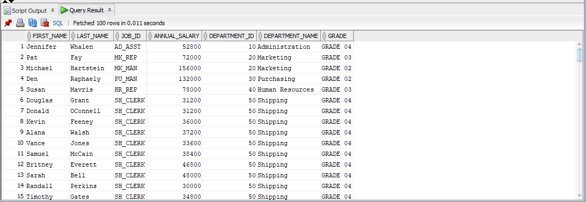

**Task#08:**

SELECT e.FIRST_NAME, m.FIRST_NAME AS MANAGER_NAME, e.HIRE_DATE AS EMP_HIRE_DATE, m.HIRE_DATE AS MAN_HIRE_DATE

FROM HR.EMPLOYEES e INNER JOIN HR.EMPLOYEES m ON (e.MANAGER_ID = m.EMPLOYEE_ID)

WHERE E.HIRE_DATE < m.HIRE_DATE;

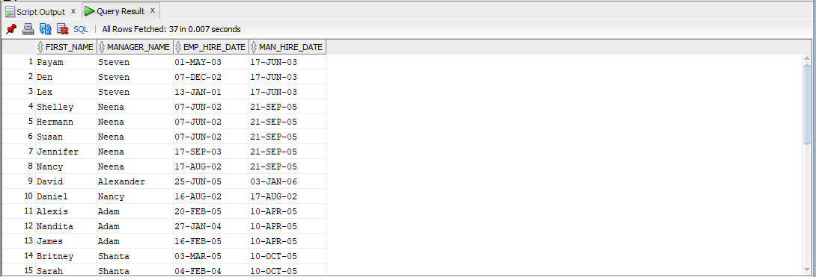

**Task#09:**

SELECT e.FIRST_NAME, e.LAST_NAME, e.SALARY , d.DEPARTMENT_NAME,

CASE WHEN e.SALARY > 20000 THEN 'GRADE 01'

WHEN e.SALARY > 10000 THEN 'GRADE 02'

WHEN e.SALARY > 5000 THEN 'GRADE 03'

ELSE 'GRADE 04' END

AS GRADE

FROM HR.EMPLOYEES e INNER JOIN HR.DEPARTMENTS d ON e.DEPARTMENT_ID = d.DEPARTMENT_ID

WHERE e.SALARY BETWEEN 10001 AND 20001;

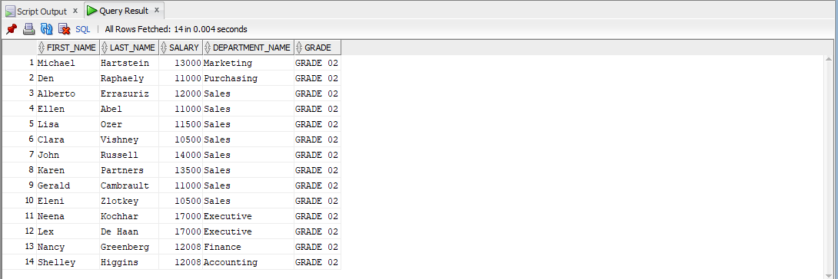

**Task#10:**

SELECT e.FIRST_NAME, e.LAST_NAME, e.JOB_ID, e.SALARY , d.DEPARTMENT_NAME,

CASE WHEN e.SALARY > 20000 THEN 'GRADE 01'

WHEN e.SALARY > 10000 THEN 'GRADE 02'

WHEN e.SALARY > 5000 THEN 'GRADE 03'

ELSE 'GRADE 04' END

AS GRADE

FROM HR.EMPLOYEES e INNER JOIN HR.DEPARTMENTS d ON e.DEPARTMENT_ID = d.DEPARTMENT_ID

ORDER BY d.DEPARTMENT_NAME;

